# Dufresne Use Cases

**General Operations**

* Switch View
* Close program

**Ledger (File) Operations**

* Create new ledger
* Save ledger
* Save ledger as
* Open ledger
* Close ledger
* Import data
  + Import from csv B1
  + Import from csv B2

**Account Operations**

* Create new account
* View account details
* Edit account details
* Delete account
* View tree of accounts

**Transaction Operations**

* Create new transaction
* View transaction details
* Edit transaction details
* Delete transaction
* View table of transactions
* Sort transactions
  + Sort by date
  + Sort by amount
* Filter transactions
  + Filter by account
  + Filter by label
  + Filter by type
* Totalize Equity

# Design

We rely on basic accounting concepts to maintain our ledgers. The equation and formula below express the relationship between accounts. Both taken from the GNUCash documentation [1].

$$Assets - Liabilities = Equity + (Income - Expenses)$$

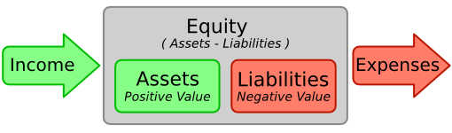

In Dufresne, a user can create accounts of four types: Income, Expense, Asset, or Liability. Equity will be derived using the above equation.

**Samples**

* **Assets**: Bank, Cash, Stocks(Currency per stock)
* **Liabilities**: CC, Car Loan
* **Expenses**: Restaurants, Rent, Random Cravings
* **Income**: Salary, Interest, Opening Balances

# Similar projects

https://github.com/ccavanaugh/jgnash/

# Bibliography

|  |  |
| --- | --- |
| [1] | GnuCash Documentation Team, "GnuCash Tutorial and Concepts Guide," 2014. [Online]. Available: http://www.gnucash.org/. |